SQL48_CODING CHALLENGE & CONTEST _ Advanced Join Skills:

Samantha interviews many candidates from different colleges using coding challenges and contests. Write a query to print the *contest_id*, *hacker_id*, *name*, and the sums of *total_submissions*, *total_accepted_submissions*, *total_views*, and *total_unique_views* for each contest sorted by *contest_id*. Exclude the contest from the result if all four sums are .

**Note:** A specific contest can be used to screen candidates at more than one college, but each college only holds  screening contest.

**Input Format**

The following tables hold interview data:

* *Contests:* The *contest_id* is the id of the contest, *hacker_id* is the id of the hacker who created the contest, and *name* is the name of the hacker.

* *Colleges:* The *college_id* is the id of the college, and *contest_id* is the id of the contest that Samantha used to screen the candidates.

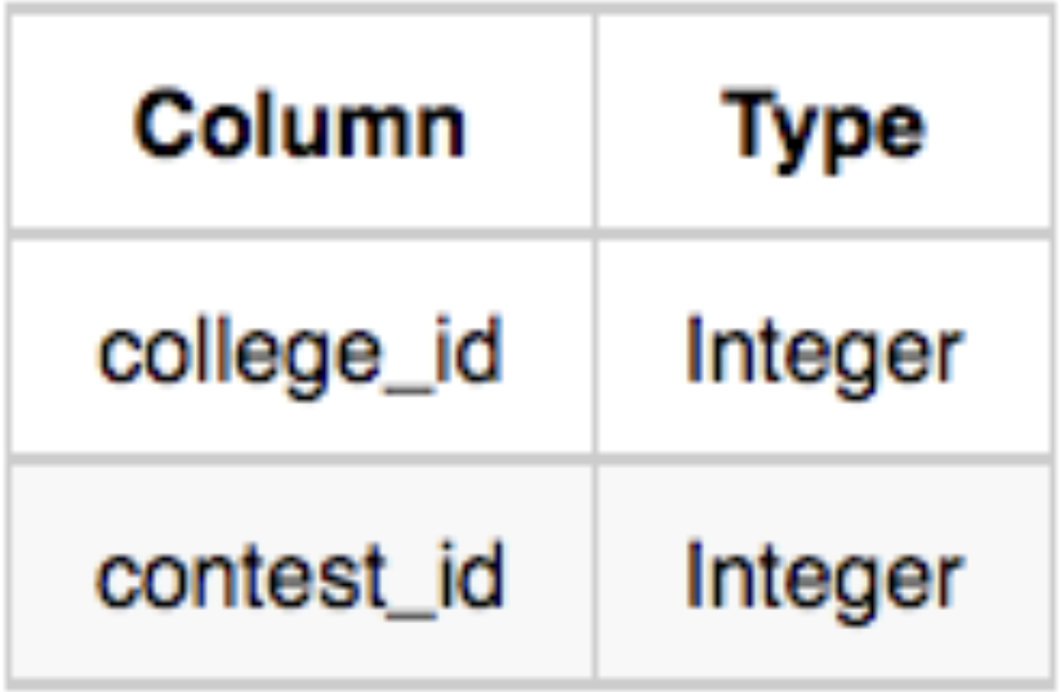

* *Challenges:* The *challenge_id* is the id of the challenge that belongs to one of the contests whose contest_id Samantha forgot, and *college_id* is the id of the college where the challenge was given to candidates.

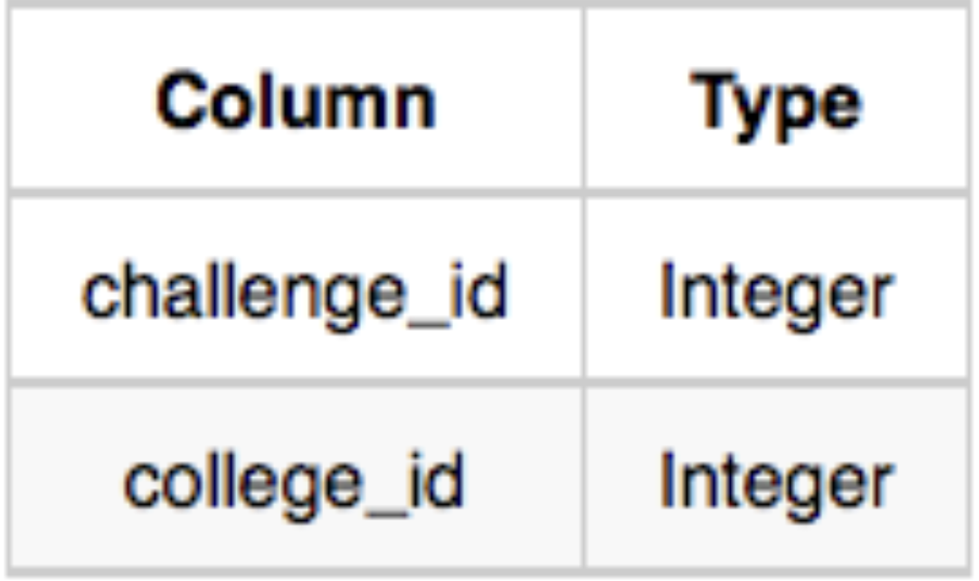

* *View_Stats:* The *challenge_id* is the id of the challenge, *total_views* is the number of times the challenge was viewed by candidates, and *total_unique_views* is the number of times the challenge was viewed by unique candidates.

* *Submission_Stats:* The *challenge_id* is the id of the challenge, *total_submissions* is the number of submissions for the challenge, and *total_accepted_submission* is the number of submissions that achieved full scores.

**Sample Input**

*Contests* Table:

*Colleges* Table:

*Challenges* Table:

*View_Stats* Table:

*Submission_Stats* Table:

**Sample Output:**

66406 17973 Rose 111 39 156 56

66556 79153 Angela 0 0 11 10

94828 80275 Frank 150 38 41 15

**Explanation:**

The contest 66406 is used in the college 11219. In this college 11219, challenges 18675 and 47127 are asked, so from the *view* and *submission* stats:

* Sum of total submissions = 27 + 56 + 28 = 111
* Sum of total accepted submissions = 10 + 18 + 11 = 39
* Sum of total views = 43 + 72 + 26 + 15 = 156
* Sum of total unique views = 10 + 13 + 19 +14 = 56

Similarly, we can find the sums for contests  66556 and 94828 .